17.116: a) Assuimg no substantial energy loss in the region between the earth and the sun, the power per unit area will be inversely proportional to the square of the distance from the center of the sun, and so the energy flux at the surface of the sun is 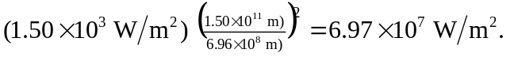 b) Solving Eq. (17.25) with 